## **Week 10 Data Entry Q1-5**

| **What is your project about?**  Renewable energy in Singapore. |
| --- |
| **What is the data you plan to use?**   * Global energy consumption patterns and sources - “Energy consumption by source, Singapore”:   + <https://ourworldindata.org/energy/country/singapore#what-sources-does-the-country-get-its-energy-from>   + I filtered the data to only reflect Singapore’s consumption levels * Infographic for pie chart - “Distribution of Solar Panels in Singapore”:   + <https://www.ema.gov.sg/singapore-energy-statistics/Ch06/index6> * Excel spreadsheet with the tabular data:   + <https://www.ema.gov.sg/assets/stat_table/SES_Public_2022.xlsx>   + I used data from Section 6 of this spreadsheet, as it corresponds to solar energy usage * Number of EV charging points as of 2022:   + <https://paultan.org/2022/09/05/singapore-now-has-over-3000-public-ev-charging-points-with-more-to-be-installed-says-countrys-lta/> |
| **What is the question you plan to answer?**  How has Singapore performed in its efforts to increase use of renewable energy, particularly in solar power and electric vehicles, and how likely is it to meet its targets in the SG Green Plan 2030? |
| **Why is this an important question?**   * According to the World Health Organisation, climate change is expected to cause approximately 250,000 additional deaths per year, from malnutrition, malaria, diarrhoea and heat stress, between 2030 and 2050. * According to the United Nations, Fossil fuels remain as the largest contributor to global climate change, accounting for over 75% of global greenhouse gas emissions and nearly 90% of all carbon dioxide emissions. * As more countries turn to renewable energy to reduce their carbon footprint, it is important to also find out what Singapore has done and is doing to reduce its own carbon footprint, especially because Singapore is a small, resource-constrained country, importing almost all its energy needs, and has limited renewable energy options, according to the National Climate Change Secretariat Singapore (NCCS) |
| **Which rows and columns of the dataset do you plan to use, to answer this question?**  (Actual names of the values you plan to filter (rows) or subset (columns) the data on)   * Excel spreadsheet with global energy consumption patterns and sources - “Energy consumption by source, Singapore”   + I plan to filter by Entity to ‘Singapore’ as Singapore is the country I want to focus on   + After that, I only included values from every 5-year interval * Excel spreadsheet with the tabular data - “SES_Public_2022”   + For the bar chart on the total number of solar panels installed in Singapore     - I used data from Section 6.2 of this spreadsheet, as it corresponds to solar energy usage     - I filtered the rows into five rows - Central, East, North, North-East, West     - I subsetted the columns to only include “year” and “no._solar_pv_inst.” which corresponds to the number of solar panels installed each year   + For the bar chart on the total capacity of installed solar panels in Singapore     - I used data from Section 6.1 of this spreadsheet     - I subsetted the columns to only include “year” and “inst_cap_mwp” which corresponds to the capacity of the solar panels that have been installed |

## **Challenges**

* I’m having some challenges with the CSS, as I’m unable to centre align some elements, such as the bullet points,

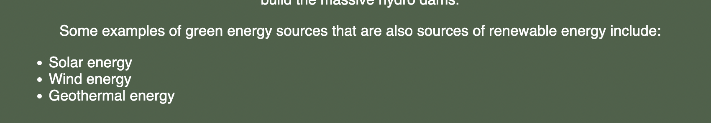

as well as the radio buttons as shown below,



and lastly, the vector graphics below.

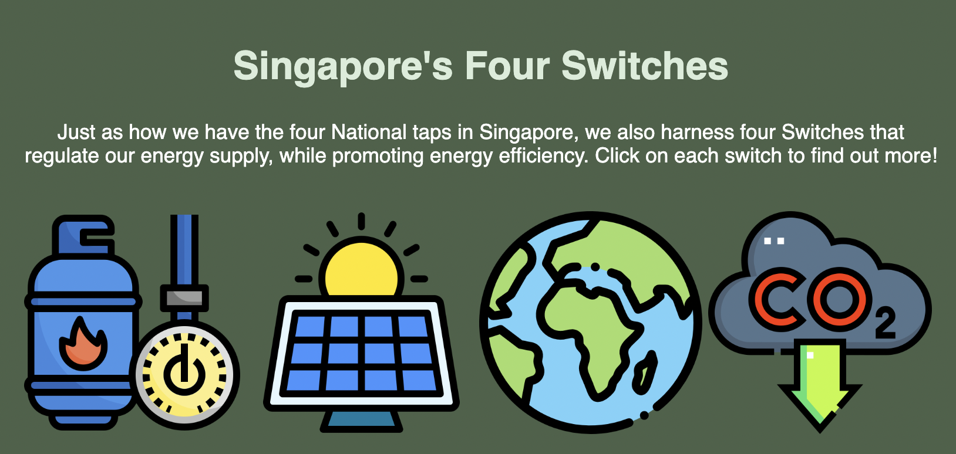

I will continue to explore different ways of formatting elements in W3schools.

* I also need to find a way to format and allow bigger margins for the bar charts, as they are too big and span the entire width of the webpage, as of now.

